- 6.7 In many architectures such as the three and four tier architectures the storage persistent objects are handled by a dedicated layer. In your opinion which design goals have led to this decision?
Ans.
- separation of concerns: each layer can focus on its specific responsibility.
- modularity: enables the separation of persistence logic from other layers.
- scalability: optimize the storage logic for efficient data storage and retrieval.
- performance: handle large volumes of data and complex queries.
- flexibility: choosing different storage technologies or databases.

- 7.1 A system that includes a web server and two database servers. Both database servers are identical the first acts as the main server while the second acts as a redundant backup in case the first one fails. Users use web browsers to access data through the web server, they also have the option of using a proprietary client that accesses the database directly draw a UML deployment diagram representing the hardware software mappings of this system.
Ans.
ClientHost - :WebBrowser ------> WebServerhost - Webserver -------> both DBServerHost- main:Database and DBServerHost - backup:Database
ClientHost - DBClient -------> both DBServerHost- main:Database and DBServerHost - backup:Database

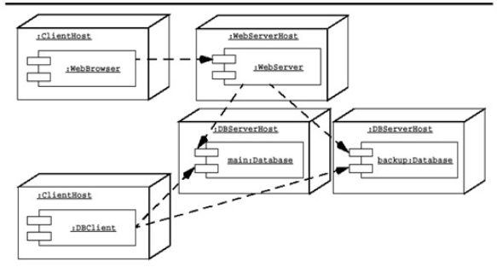

- 7.3 Design the access control policies for a web-based retail store. Customers access the store via the web for product information, input their addresses and payment information and purchase products. Suppliers can produce products, update products information and receive orders. The store owner sets the retail prices, makes offers to customers based on their purchasing profiles and provides marketing services you have to deal with actors: store administrator supplier and customer. Design an access control policy for all three actors that will be the access control matrix? Customers can be created via the web whereas suppliers are added by the store administrator.
Ans.
- An access control policy is represented with a matrix.
- The columns represent objects whose access is controlled, the rows represent the actors accessing the objects, the cells contain the operations that an actor is allowed to invoke for a specific object.
- In this exercise, there are four objects under access control: the product (including product information and price), the customer information, the supplier information, and the order.
- There are four actors which should be considered:
  - the three actors mentioned in the exercise and the unregistered web user which can browse the product catalog and the create a new customer (as indicated in the last sentence of the exercise. Table 7-1 depicts a possible access matrix for the text above.
  - The name of the operations may be different from one solution to another.
  - The instructor may consider correct solutions which merge the unregistered user row with the customer row.
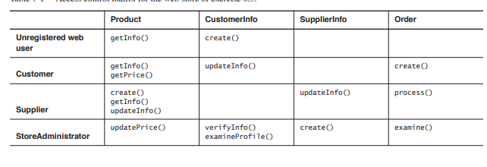

- 8.5 Consider an application that must select dynamically an encryption algorithm based on security requirements and computing time constraints. Which design pattern would you select? Draw a UML class diagram depicting the classes in the pattern and justify your choice.
Ans.
This can be interpreted as a Strategy in which two concrete strategies are identical, a Proxy pattern which interacts with an external policy object.
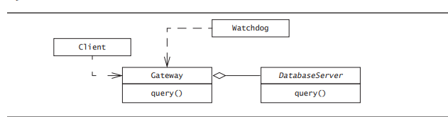

- 8.2 Indicate which occurrences of the following inheritance relationships are specifications inheritance and which are implementation inheritance
Ans.
A rectangle class inherits from a polygon class [specification inheritance]
A set class inherits from a binary tree class . [implementation inheritance]
A set class inherits from a bag class [specification inheritance]
A player class inherits from a user class [specification inheritance]
A window class is inherited from a polygon class. [implementation inheritance]
9.4 Consider a rectangle class and a square class that inherits from a rectangle class Ans.
  - Write post conditions for the rectangle set with and the rectangle set height
    - Context Rectangle::setWidth(w)
    - post: w = getWidth() and getHeight() = @pre.getHeight()
    - Context Rectangle::setHeight(h)
    - post: h = getHeight() and getWidth() = @pre.getWidth()
  - Write an invariant for the square class stating that the with and height of the square should always be the same
    - Context: Square
    - inv: getWidth() = getHeight()
- 9.7 Consider a simple intersection with two crossing roads and four traffic lights. Assume a simple algorithm for switching lights so that the traffic on one road can proceed while the traffic on the other road is stopped model each traffic light as an inheritance of a traffic light class with a state attribute that can be wither red yellow green write in QCL on the state attribute traffic light class that guarantees the traffic cannot proceed on both roads simultaneously add associations to the model to navigate the system if necessary note that the OCL constraints are written on classes as opposed to instances
- We add an association called right to denote the traffic light on the road to the right. Hence, the expression right.right denotes the opposing light.
- /* Opposing lights have always the same state */
- context TrafficLight inv: state = right.right.state
- /* If the current light is green or yellow, the light on the right must be red */
- context TrafficLight inv: (state = #green or state = #yellow) implies right.state = #red
- 3.8 What’s the difference between a cross functional team and a subsystem team? Provide examples and justify your choices
- A subsystem team is completely responsible for the development of a subsystem.
- A cross-functional team is made out of liaison of subsystem teams and is responsible for support tasks, such as documentation and configuration management.
- Also, the system architecture can is often defined by a cross-functional team made out of liaison from all subsystem teams
- 5.4 Examine the sequence diagram in following sequence diagram identify the association between these objects, the association can them be represented on a class diagram for these objects.
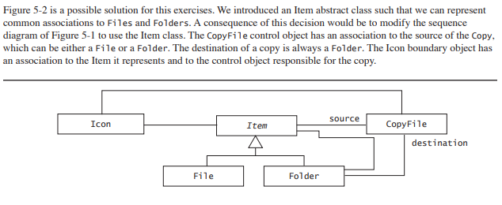

- Consider an online reservation system TRS for a travel company. List and provide rationale for the three design goals for the above system. Briefly discuss and two of them are in conflict. Preform subsystem decomposition for the above system with a UML diagram, state any architectural styles used
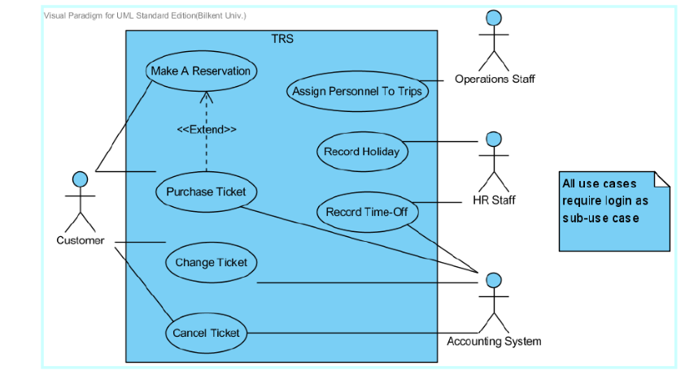
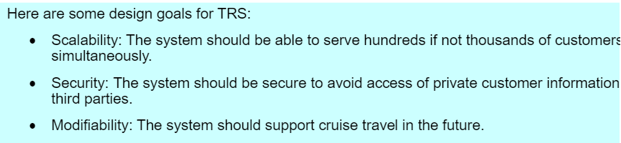

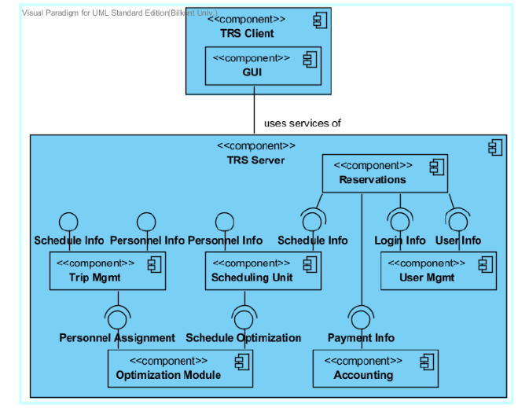
- 6.5 Discuss how the MVC architecture helps or hurts the following design goals
  - Extensibility
  - Response time
  - Modifiability
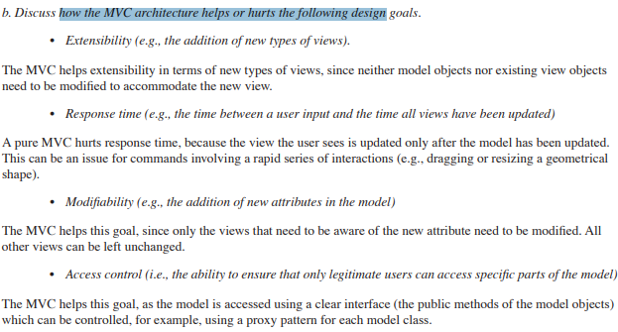
  - Access control

- What are similarities and differences between an adapter design pattern and a bridge design pattern?
  - a bridge pattern serves to decouple an abstraction class from its implementation
  - an adaptor pattern converts the interface between classes with less inheritance
- When we convert the client server architecture style to the peer-to-peer architectural style we need to introduce a new abstraction peer, the peer can be depicted as the following class
  - Which proposal would you choose? Please explain why you would choose that one.
  - Proposal 2 is best; a peer can be both client or server not directly deciding one or the other

- Below is an UML model describing the typical organization of class modules taken by a student.
  - Modules can be taken if and only if they have more than seven students registering
  - The assessment for a module must total 100%
  - Students must register for a total of 120 credits each year
  - Students must take at least 90 credits for cs modules each year
  - All modules must have at least one assessment worth over 50%
